

**UNIVERSITY OF PETROLEUM AND ENERGY STUDIES**

**School of Computer** **Science**

**2020-21**

**GRAPHICS AND ANIMATION TOOLS LAB**

**Faculty: Dr. DURGANSH SHARMA**

**Assistant Professor**

**Department of Cybernetics.**

**School of Computer Science, UPES**

**Submitted By:**

**Name- Varini Mittal**

**Roll no-R100217087**

**Batch-B3**

**Semester- 7**

**Course-B.tech. CSE-OSOS**

**Sap Id- 500062569**

**Experiments -1 Installation of GIMP AND BLENDER.**

**Installation of GIMP:**

**Step - 1:**

Visit the website to download gimp.

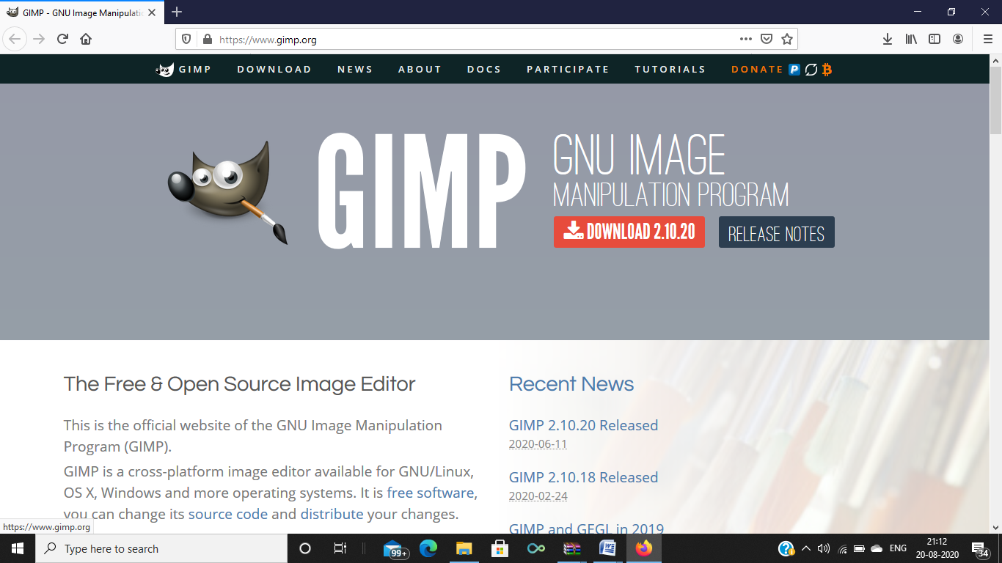

**Step - 2-:**

Click on the download 2.10.20 and then click on save file.

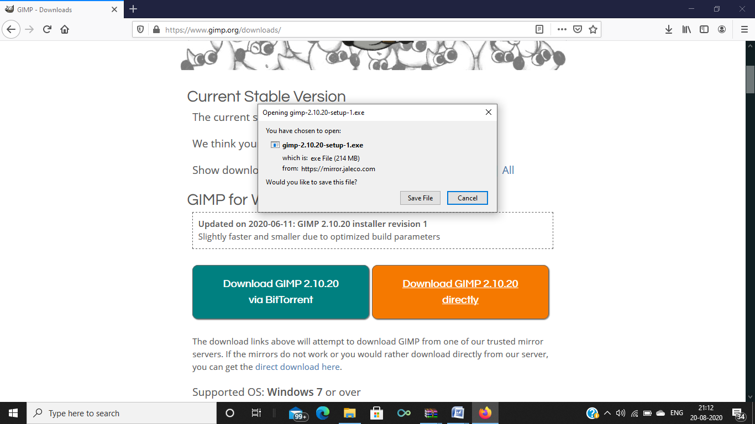

**Step – 3-:**

A set up window will get opened up after the exe file gets downloaded. Then click on the install button.

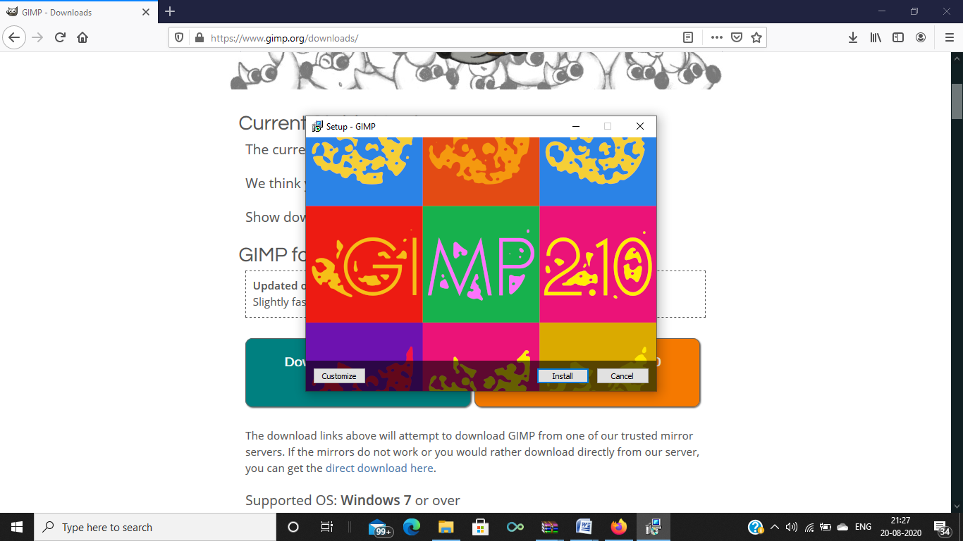

**Step – 4-:**

Click on finish to complete the installation.

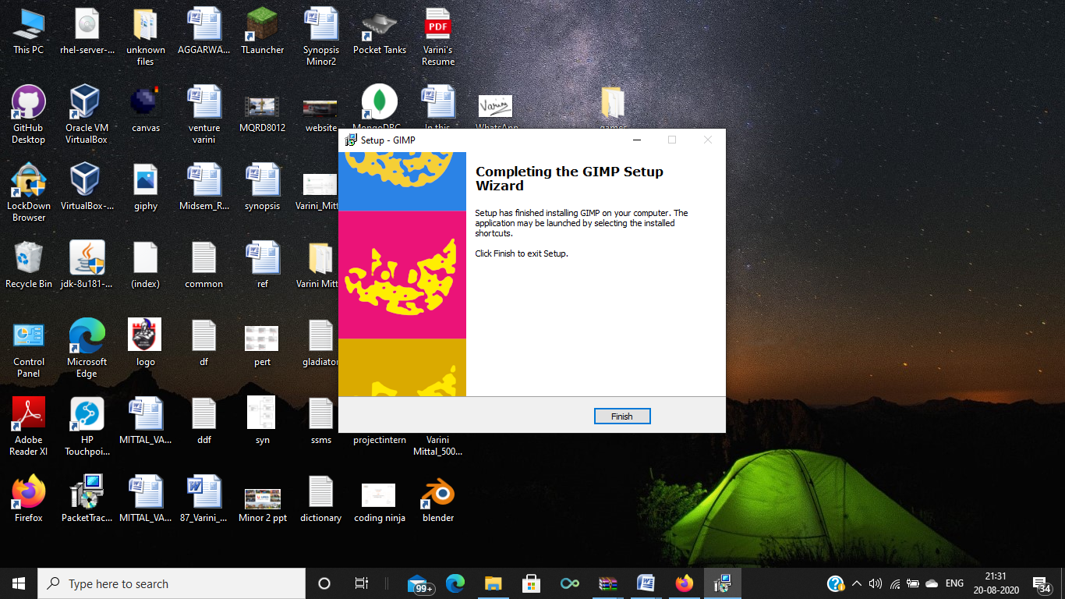

**Step – 5:**

Start using GIMP. Once GIMP has finished installing, you can start using it.

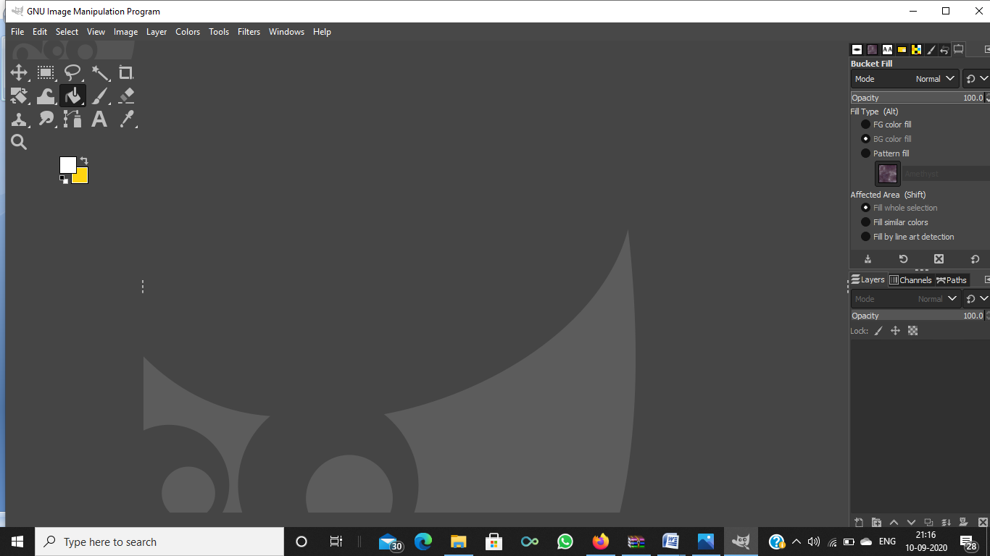

**Installation of BLENDER:**

**Step – 1:**

Visit the Blender website.

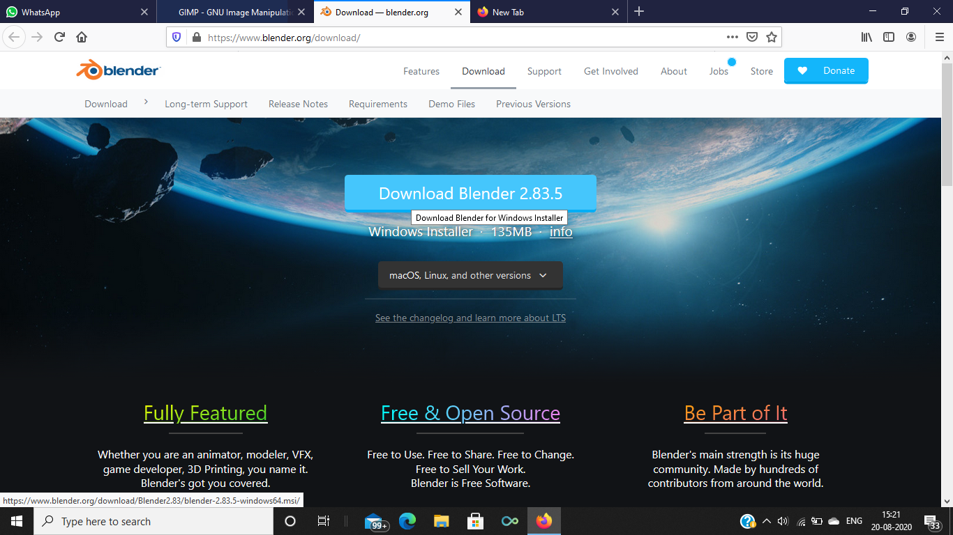

**Step – 2:**

After complete downloading of exe file, Blender setup wizard will open up. Click on next.

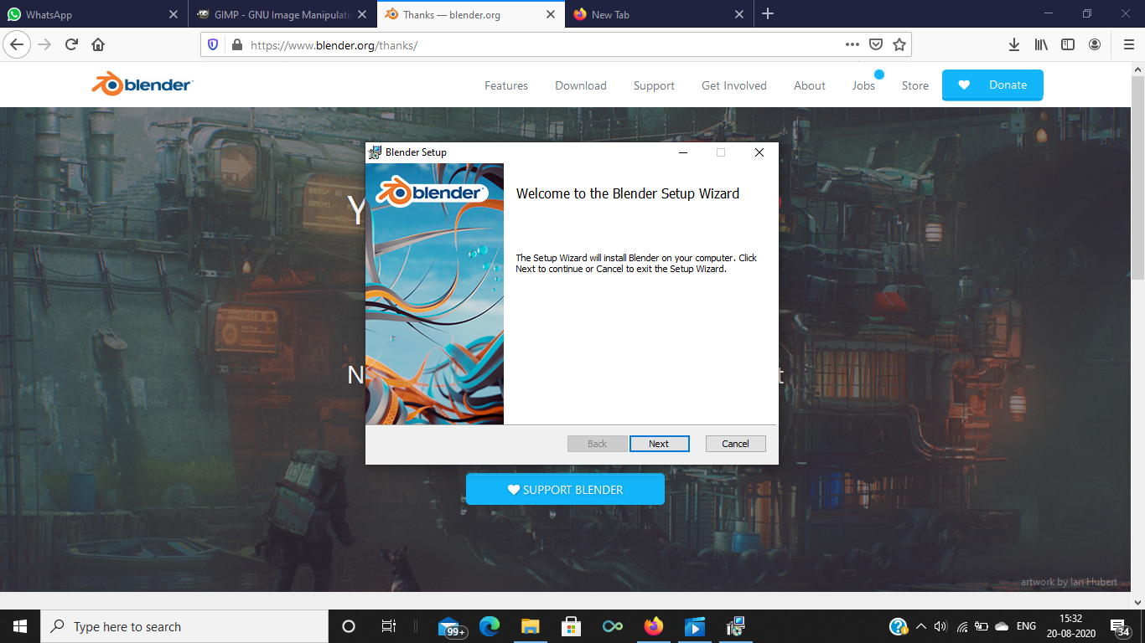

**Step – 3-:**

Accept the terms in the license agreement and click on next. Then, click on install.

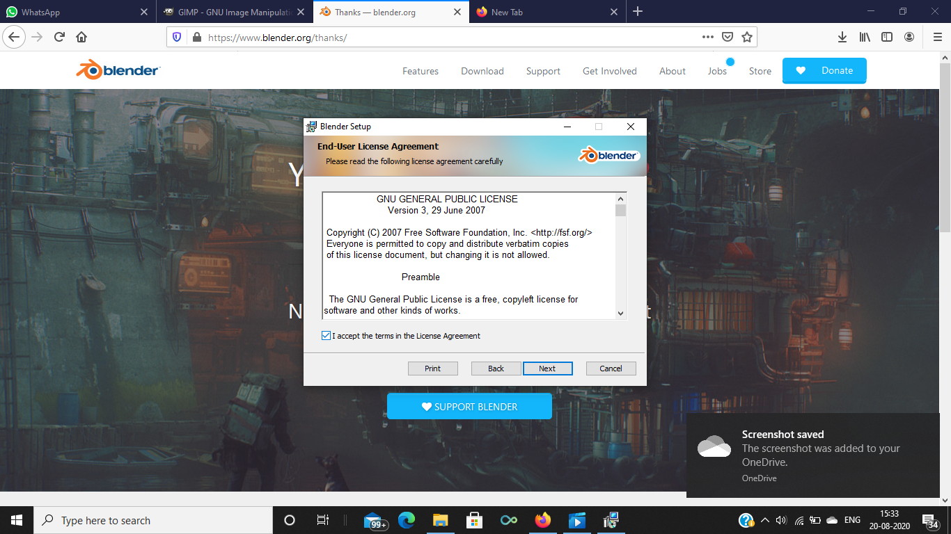

**Step -4 -:**

Click on install.

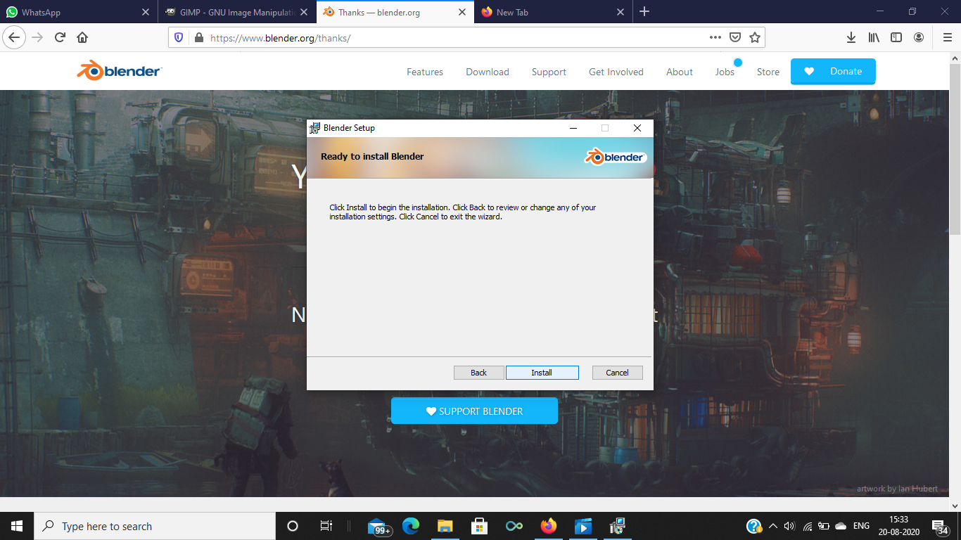

**Step – 5-:**

Blender will be installed. Open the application. It will look like this –

